**Research Integrity – HDR Students Training on Blackboard**

***Instructions on how to self-enrol and complete the training***

***How to self-enrol in the ‘Research Integrity – HDR 2020’***

1. Log into Student OASIS <https://oasis.curtin.edu.au/Auth/LogOn>   
   Click on the link to Blackboard.  Your Blackboard home page will load.
2. Navigate to the Organisations Tab

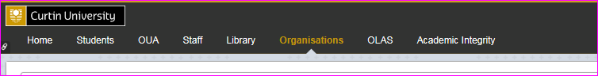

1. On the right hand side of the screen you will see ‘Organisation Catalogue’. Select ‘Browse Organisation Catalogue’  
     
   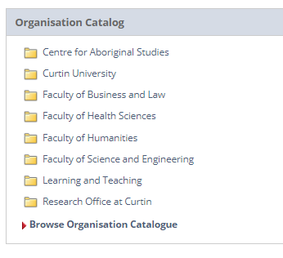
2. Type ‘HDR 2020’ in the Organisation Search field. This will bring up the *Research Integrity – HDR 2020.*
3. Under column ‘Organisation ID”, hover over the ‘Research_int_HDR_org to display the downward arrow, and then select Enrol.

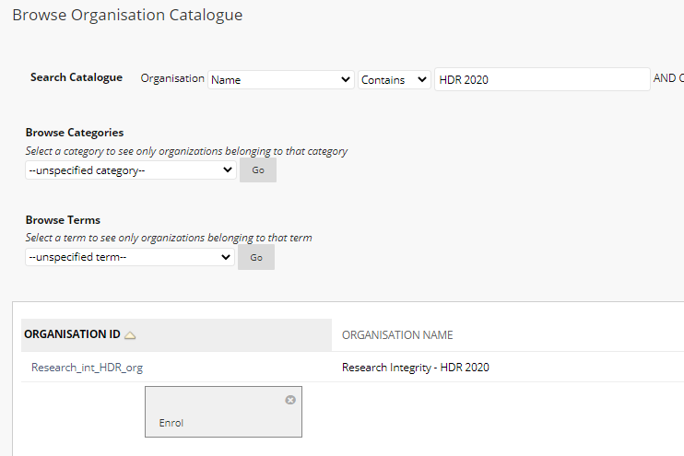

1. You will now have access to the organisation: *Research Integrity – HDR 2020*. To find it, open the Organisations tab, look under the 'My Organisations' section. It can also be found on the **Home** tab.

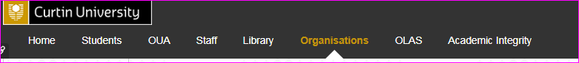

If you have problems accessing the *Research Integrity – HDR 2020* training on Blackboard, please email [ROC-Excellence@curtin.edu.au](mailto:grs.training@curtin.edu.au)

***Does the web browser matter?***

When using Blackboard, the recommended web browsers are Google Chrome, Firefox or Safari. Avoid using Internet Explorer or Edge.

***Need help?***

* If you cannot self-enrol in ‘Research Integrity – HDR 2020’, or cannot see it listed under the heading ‘My Organisations’, or if you have any other questions about the training, please contact [ROC-Excellence@curtin.edu.au](mailto:grs.training@curtin.edu.au)

***I’ve logged into the unit, what do I do now?***

The unit Menu (on the left-hand-side) displays the contents for the course:

* **Announcements** - information about completion of the unit
* **Contacts**
* **Unit** M**aterials** – (includes 13 short courses, with a Quiz for each course.
* **My Grades** - shows the Pass/Fail result once a user has submitted the quiz.  A Pass grade is awarded where a minimum of 80% of questions are answered correctly
* **Originality Checking** – contains links to Turnitin for uploading documents
* **Turnitin How-to videos**
* **Studiosity** link (for online research writing help)

Click on **Unit Materials** to access the series of 13 courses

• The Responsible Conduct of Research  
• When Things Go Wrong: Breaches of the Code  
• Planning Your Research  
• Managing and Recording Your Research  
• Data Selection, Analysis and Presentation  
• Scholarly Publication  
• Professional Responsibilities  
• Communication and Social Responsibility  
• Conflicts of Interest  
• Responsible Conduct of Human Participants Research  
• The Care and Use of Animals in Research  
• Intellectual Property  
• Export Controls

Starting at the top ‘The Responsible Conduct of Research’, read/work through the material for each course, then complete the quiz at the end of each course.    Once you have passed the first quiz, this will unlock the next course, and so on).

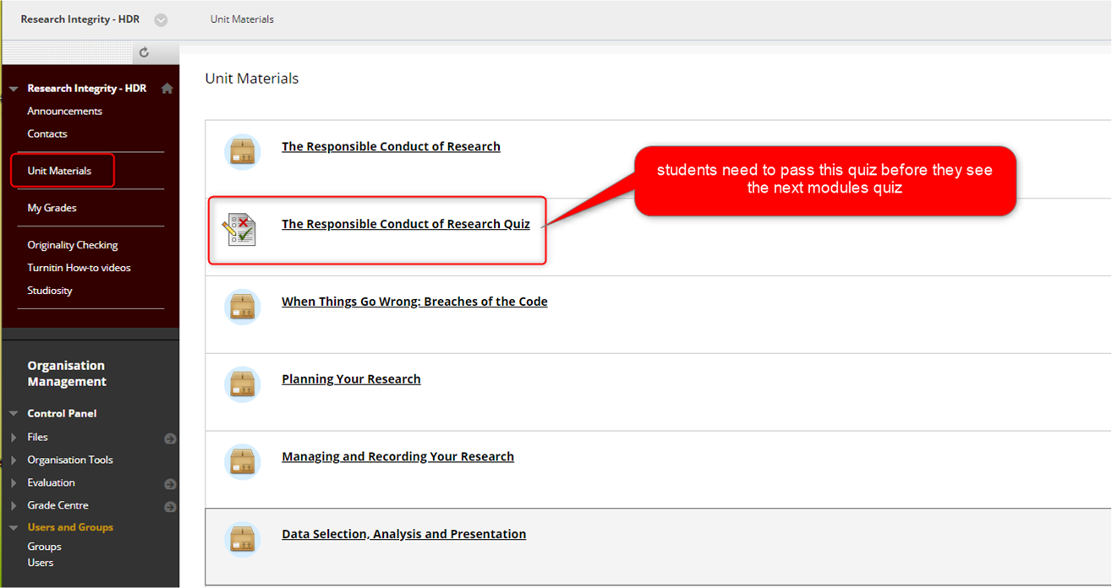

***What do the course quizzes involve?***

* Each quiz contains 10 multiple-choice questions.
* You must achieve 80% to pass each individual quiz (8/10).
* Each quiz can be saved and resumed later
* Each quiz allows multiple attempts until a pass is achieved for that quiz
* **My Grades** (in the left hand menu) - the result for the quiz will show as a score out of 10. You must score a minimum of 8/10 (80%) to pass a quiz
* When you have passed all 13 quizzes, your Final Grade will say ‘Pass’.
* To view/print your Pass result, click on ‘My Grades’ and select **all**.  If you are submitting an ethics application, you will need to attach a copy of the screen shot.

***How to print your Pass result***

There are no certificates in Blackboard for this training. Instead, please take a screen shot of your Pass result.

In the left hand menu, select ‘My Grades’ and then ‘All’ (your name will be displayed in the top right hand corner)

When taking a screen shot, ensure the following 3 pieces of information are included:

1. The name of the training appears at the top of the left hand menu “Research Integrity – HDR 2020”,
2. Your name - which appears in the top right hand corner of the Blackboard screen,
3. ‘Pass’.